***Syed Muhammad Sarim***

***DLD Lab 2 Task***

***24K-0718***

***Task 1:***

***Z = ((AB+CD)’+B’)C’***

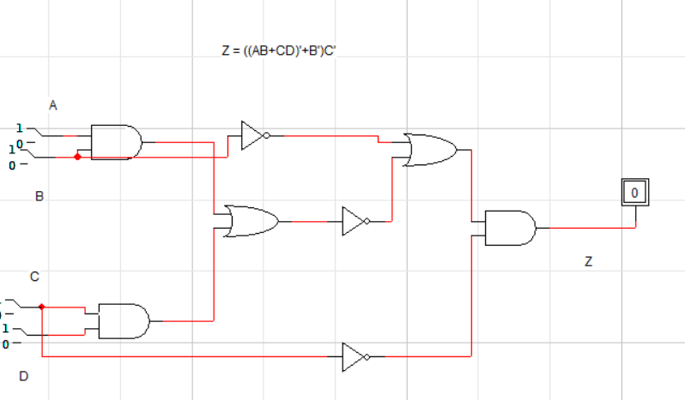

***Truth Table:***

|  |  |  |  |  |
| --- | --- | --- | --- | --- |
| ***A*** | ***B*** | ***C*** | ***D*** | ***Z*** |
| ***0*** | ***0*** | ***0*** | ***0*** | ***1*** |
| ***0*** | ***0*** | ***0*** | ***1*** | ***1*** |
| ***0*** | ***0*** | ***1*** | ***0*** | ***0*** |
| ***0*** | ***0*** | ***1*** | ***1*** | ***0*** |
| ***0*** | ***1*** | ***0*** | ***0*** | ***1*** |
| ***0*** | ***1*** | ***0*** | ***1*** | ***1*** |
| ***0*** | ***1*** | ***1*** | ***0*** | ***0*** |
| ***0*** | ***1*** | ***1*** | ***1*** | ***0*** |
| ***1*** | ***0*** | ***0*** | ***0*** | ***1*** |
| ***1*** | ***0*** | ***0*** | ***1*** | ***1*** |
| ***1*** | ***0*** | ***1*** | ***0*** | ***0*** |
| ***1*** | ***0*** | ***1*** | ***1*** | ***0*** |
| ***1*** | ***1*** | ***0*** | ***0*** | ***0*** |
| ***1*** | ***1*** | ***0*** | ***1*** | ***0*** |
| ***1*** | ***1*** | ***1*** | ***0*** | ***0*** |
| ***1*** | ***1*** | ***1*** | ***1*** | ***0*** |

***Post Lab Task:***

***Task 2:***

***1.(A+B)(C+D)***

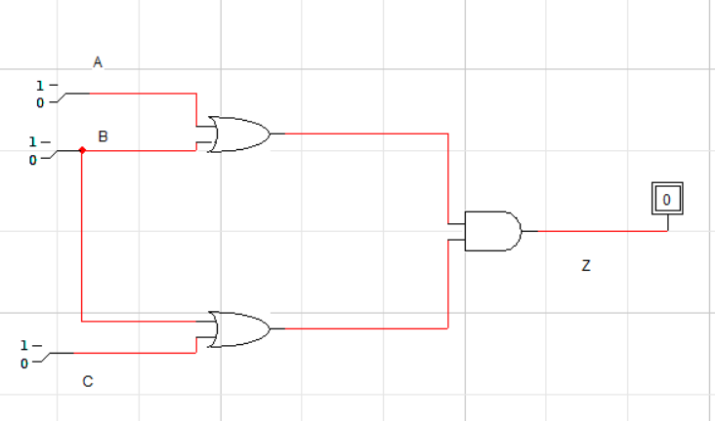

|  |  |  |  |
| --- | --- | --- | --- |
| ***A*** | ***B*** | ***C*** | ***Z*** |
| ***0*** | ***0*** | ***0*** | ***0*** |
| ***0*** | ***0*** | ***1*** | ***0*** |
| ***0*** | ***1*** | ***0*** | ***1*** |
| ***0*** | ***1*** | ***1*** | ***1*** |
| ***1*** | ***0*** | ***0*** | ***0*** |
| ***1*** | ***0*** | ***1*** | ***1*** |
| ***1*** | ***1*** | ***0*** | ***1*** |
| ***1*** | ***1*** | ***1*** | ***1*** |

***2.((AB)+C)D***

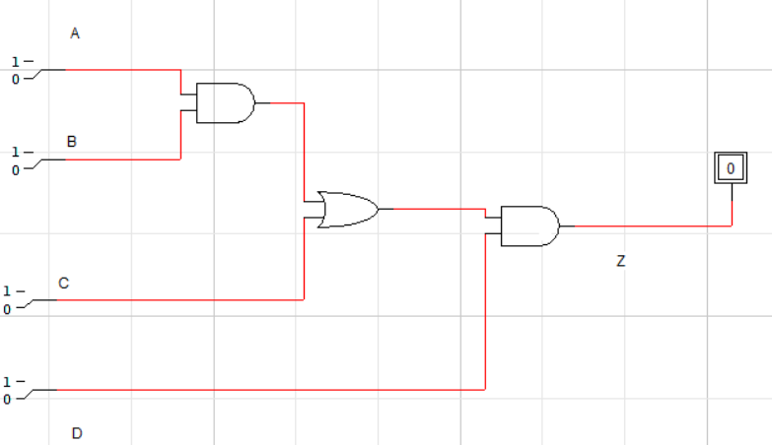

***Truth Table:***

|  |  |  |  |  |
| --- | --- | --- | --- | --- |
| ***A*** | ***B*** | ***C*** | ***D*** | ***Z*** |
| ***0*** | ***0*** | ***0*** | ***0*** | ***0*** |
| ***0*** | ***0*** | ***0*** | ***1*** | ***0*** |
| ***0*** | ***0*** | ***1*** | ***0*** | ***0*** |
| ***0*** | ***0*** | ***1*** | ***1*** | ***1*** |
| ***0*** | ***1*** | ***0*** | ***0*** | ***0*** |
| ***0*** | ***1*** | ***0*** | ***1*** | ***0*** |
| ***0*** | ***1*** | ***1*** | ***0*** | ***0*** |
| ***0*** | ***1*** | ***1*** | ***1*** | ***1*** |
| ***1*** | ***0*** | ***0*** | ***0*** | ***0*** |
| ***1*** | ***0*** | ***0*** | ***1*** | ***0*** |
| ***1*** | ***0*** | ***1*** | ***0*** | ***0*** |
| ***1*** | ***0*** | ***1*** | ***1*** | ***1*** |
| ***1*** | ***1*** | ***0*** | ***0*** | ***0*** |
| ***1*** | ***1*** | ***0*** | ***1*** | ***1*** |
| ***1*** | ***1*** | ***1*** | ***0*** | ***0*** |
| ***1*** | ***1*** | ***1*** | ***1*** | ***1*** |

***3. ((A + B’C) (A + BC))’***

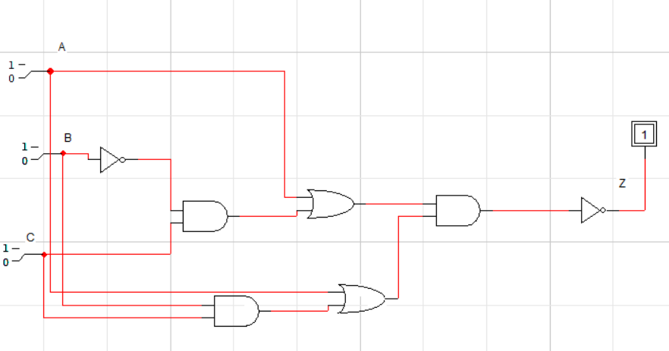***Truth Table:***

|  |  |  |  |
| --- | --- | --- | --- |
| ***A*** | ***B*** | ***C*** | ***Z*** |
| ***0*** | ***0*** | ***0*** | ***1*** |
| ***0*** | ***0*** | ***1*** | ***1*** |
| ***0*** | ***1*** | ***0*** | ***1*** |
| ***0*** | ***1*** | ***1*** | ***1*** |
| ***1*** | ***0*** | ***0*** | ***0*** |
| ***1*** | ***0*** | ***1*** | ***0*** |
| ***1*** | ***1*** | ***0*** | ***0*** |
| ***1*** | ***1*** | ***1*** | ***0*** |

***4.*** ***A’BC + AB’C + ABC’ + (ABC)’***

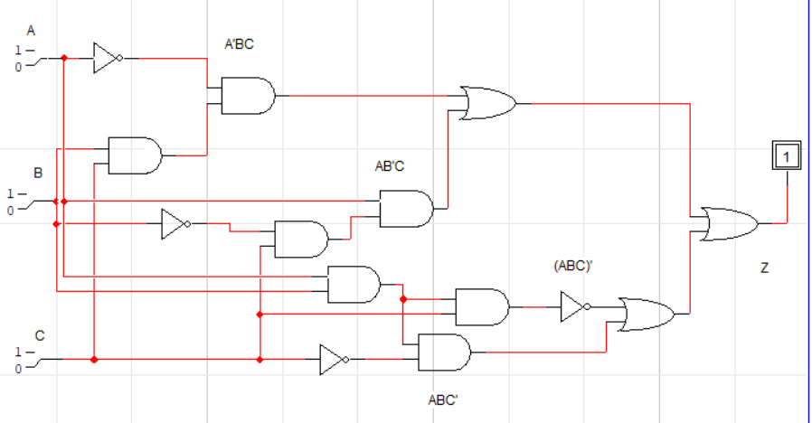

***Truth Table:***

|  |  |  |  |
| --- | --- | --- | --- |
| ***A*** | ***B*** | ***C*** | ***Z*** |
| ***0*** | ***0*** | ***0*** | ***1*** |
| ***0*** | ***0*** | ***1*** | ***1*** |
| ***0*** | ***1*** | ***0*** | ***1*** |
| ***0*** | ***1*** | ***1*** | ***1*** |
| ***1*** | ***0*** | ***0*** | ***1*** |
| ***1*** | ***0*** | ***1*** | ***1*** |
| ***1*** | ***1*** | ***0*** | ***1*** |
| ***1*** | ***1*** | ***1*** | ***0*** |

***5. (A’ + BC)’***

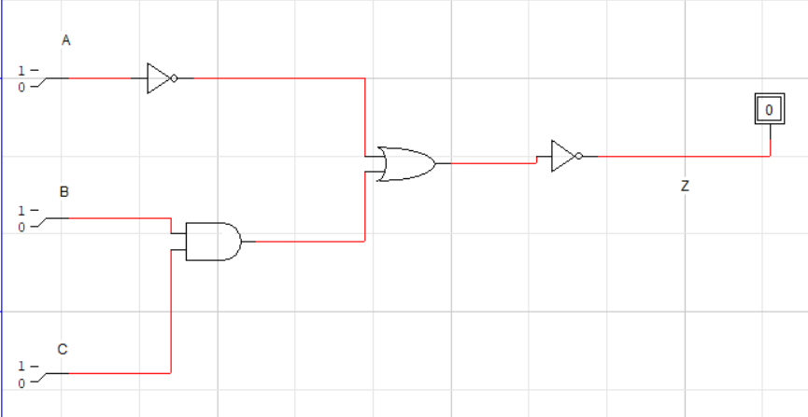

***Truth Table:***

|  |  |  |  |
| --- | --- | --- | --- |
| ***A*** | ***B*** | ***C*** | ***Z*** |
| ***0*** | ***0*** | ***0*** | ***0*** |
| ***0*** | ***0*** | ***1*** | ***0*** |
| ***0*** | ***1*** | ***0*** | ***0*** |
| ***0*** | ***1*** | ***1*** | ***0*** |
| ***1*** | ***0*** | ***0*** | ***1*** |
| ***1*** | ***0*** | ***1*** | ***1*** |
| ***1*** | ***1*** | ***0*** | ***1*** |
| ***1*** | ***1*** | ***1*** | ***0*** |

